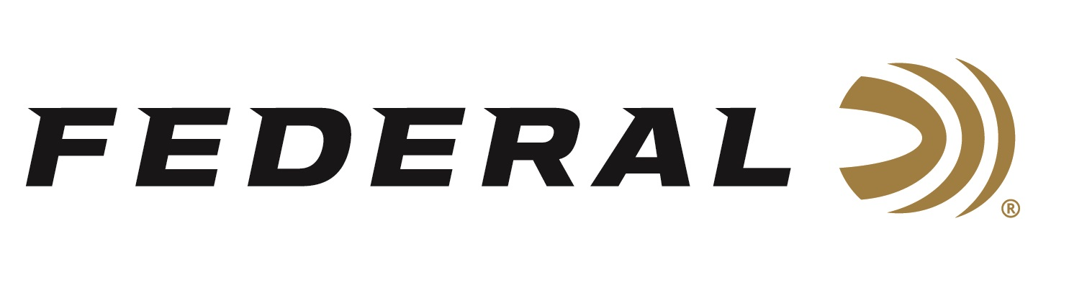

FOR IMMEDIATE RELEASE

Federal Ammunition Introduces New Swift Scirocco II

ANOKA, Minnesota – November 24, 2020 – Federal Premium releases its new Swift Scirocco II centerfire hunting loads lineup. The new bullet promises to push effective range to new extremes while delivering a more lethal blow on impact. Shipments of this product have been arriving at dealers nationwide.

“We are happy to have partnered with Swift to load this fantastic long-range hunting bullet. Swift is known for bonded-core hunting bullets and is one of several Swift bullets that we load into our Federal Premium lineup,” said Federal’s Centerfire Rifle Product Manager Eric Miller. “The Swift Scirocco II produces excellent upsets at various distances and is an all-around, good choice for medium and big-game hunting.”

The Swift Scirocco II bullet’s streamlined design and high ballistic coefficient produce flat trajectories, while retaining more velocity and energy downrange. Aided by its proprietary polymer tip, the Scirocco II expands at minimal velocities yet offers high weight retention at close range thanks to its bonded copper jacket.

Features & Benefits
- Proprietary polymer tip improves ballistics and initiates low-velocity expansion
- Advanced secant ogive maximizes ballistic coefficient
- Tapered copper jacket bonded to lead core
- High weight retention at close range
- Expands reliably at low velocity for long-range terminal effect

Part No. / Description / MSRP
P243SS1 / 243 Win 90-grain Scirocco II; 3,100 fps, .419 BC, 20-count / $54.99
P65CRDSS1 / 6.5 CM 130-grain Scirocco II; 2800 fps, .571 BC, 20-count / $55.99
P270SS1 / 270 Win 130-grain Scirocco II; 3,060 fps, .450 BC, 20-count / $55.99
P270WSMSS1 / 270 WSM 130-grain Scirocco II; 3,280 fps, .450 BC, 20-count / $65.99
P7RSS1 / 7mm Rem Mag150-grain Scirocco II; 3,035 fps, .525 BC, 20-count / $56.99
P308SS1 / 308 Win165-grain Scirocco II; 2,880 fps, .470 BC, 20-count / $53.99
P3006SS1 / 30-06 Sprg 165-grain Scirocco II; 3,000 fps, .470 BC, 20-count / $57.99
P300WSS1 / 300 Win Mag 180-grain Scirocco II; 2,960 fps, .520 BC, 20-count / $61.99
P300WSMSS1 / 300 WSM 180-grain Scirocco II; 2,960 fps, .520 BC, 20-count / $56.99
https://www.federalpremium.com/search?q=+Scriocco&search-button=&lang=default

Federal ammunition can be found at dealers nationwide or purchased online direct from Federal. For more information on all products from Federal or to shop online, visit www.federalpremium.com.

Press Release Contact: JJ Reich
Senior Manager – Press Relations
E-mail: VistaPressroom@VistaOutdoor.com

About Federal Ammunition
Federal, headquartered in Anoka, MN, is a brand of Vista Outdoor Inc., an outdoor sports and recreation company. From humble beginnings nestled among the lakes and woods of Minnesota, Federal Ammunition has evolved into one of the world's largest producers of sporting ammunition. Beginning in 1922, founding president, Charles L. Horn, paved the way for our success. Today, Federal carries on Horn's vision for quality products and service with the next generation of outdoorsmen and women. We maintain our position as experts in the science of ammunition production. Every day we manufacture products to enhance our customers' shooting experience while partnering with the conservation organizations that protect and support our outdoor heritage. We offer thousands of options in our Federal Premium and Federal® lines-it's what makes us the most complete ammunition company in the business and provides our customers with a choice no matter their pursuit.

